Lanigan 2018 Popcorn Key Info
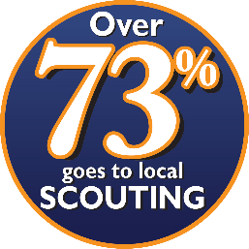
Kernel Mike Imel Contact Info
28164 Wildwood Trail (North of 10mile)
Farmington Hills, MI 48336-2157

Call/text: (248)508-7328
Email: Pack231Popcorn@gmail.com
_____________________________________________________________________________________
Store Front Sales
Saturday September 15th at the Farmer's Market (9-3ish)
Saturday September 29th at Fresh Thyme downtown Farmington (12-5)
Sunday September 30th at Kroger on 11mi (4-8)
Saturday October 6th at Kroger on 11mi (4-8)
Sunday October 7th at Kroger on 11mi (8-8)
Look for sign up genius emails to sign up for an hr. I ask you mix up the Dens so older Scouts can help the younger Scouts.
_____________________________________________________________________________________
Call/text/email if you’d like to take out some popcorn to sell in the neighborhood.
I will consider this sold to your Scout, but I will take undamaged/unopened popcorn back before Tuesday October 23rd. (To be counted and given to other Scouts to sell before the final order)
_____________________________________________________________________________________
Order forms due back to Mike Imel by Tuesday, October 23rd. Note: This will be the only subsequent order!
Final order pick up will be November 10th-11th. If you can’t make this weekend, please let me know.
All payments must be made to Pack Leader, Asst Pack Leader or Kernel by Tuesday, November 27th.
Prize selection must be made to the Kernel (text/email) by Tuesday December 11th.
_____________________________________________________________________________________
Sell online! The pack gets 50% of those sales! All sales count towards the prizes.
https://www.trails-end.com/how-it-works

Remember, you are selling Scouting Adventures, not Popcorn!!!

Continuing in 2018!
We will be capable of taking Credit Card payments!

We will use the service provided by Square. These purchases require a small added fee to cover the costs from Square.
Benefits:
Increased sales! Funds are tracked to Scout.
Requirements:
Must use your own compatible phone, at your expense. Scouting/Square will not be able to reimburse for any data charges as a result of using the app. (Note: This does not apply to Store Front sales)
Go to Square to learn if your phone is compatible. (https://squareup.com/help/us/en/article/3887)

I have readers available to loan out. Please see Kernel Mike Imel to set up your device. You will log in w/ a Device Code so I know who is who.

